
Gara6

Version 1.0

Software Requirements Specification

Version 1.0
07.03.2022

The Powerpuff Girls
(Plamena Georgieva – 1801261063 – UX/UI Designer, QA, Analyst;
Katerina Raztsvetnikova – 1801261055 – Project Manager, Developer, Analyst)

Table of Contents
1. Introduction 4
1.1 Purpose 4
1.2 Scope 4
1.3 Overview 5
2. Overall Description 6
2.1 Use-Case Model Survey 6
2.2 Gantt Chart 9
2.3 Time Table 9
2.4 ER diagram 11
2.5 Data Dictionary 12
2.6 Assumptions and Dependencies 14
3. Specific Requirements 15
3.1 Use-Case Reports 15
3.2 Class Diagram 38
3.2 Supplementary Requirements 39

1. Introduction

Purpose
The purpose of this document is to present a detailed description of the Vehicle management platform. It will explain the purpose and features of the platform, the interfaces of the platform, what the platform will do, the constraints under which it must operate and how the platform will react to external stimuli. This document is intended for both the stakeholders and the developers of the platform.

Scope
This software platform will be a vehicle management platform. It will be designed to help people organize everything about their vehicles / parks. It will provide an easy and convenient way to introduce liability insurance, annual technical inspection, tax, vignette, tracking fuel consumption by various indicators, filling in a digital roadmap that covers the norms set in the legislation of all of Bulgaria, creating current online service history, export. It will provide automatic reports and notifications.
More specifically, this platform will be designed to provide businesses with the detailed information needed to manage vehicles, and for users an easy way to save information about their vehicles and receive notifications about forthcoming liabilities.

Overview
The next chapter, the Overall Description section, of this document gives an overview of the functionality of the product. It describes the informal requirements and is used to establish a context for the technical requirements specification in the next chapter.
The third chapter, Requirements Specification section, of this document is written primarily for the developers and describes in technical terms the details of the functionality of the product.
Both sections of the document describe the same software product in its entirety, but are intended for different audiences and thus use different language.

Overall Description

Use-Case Model Survey

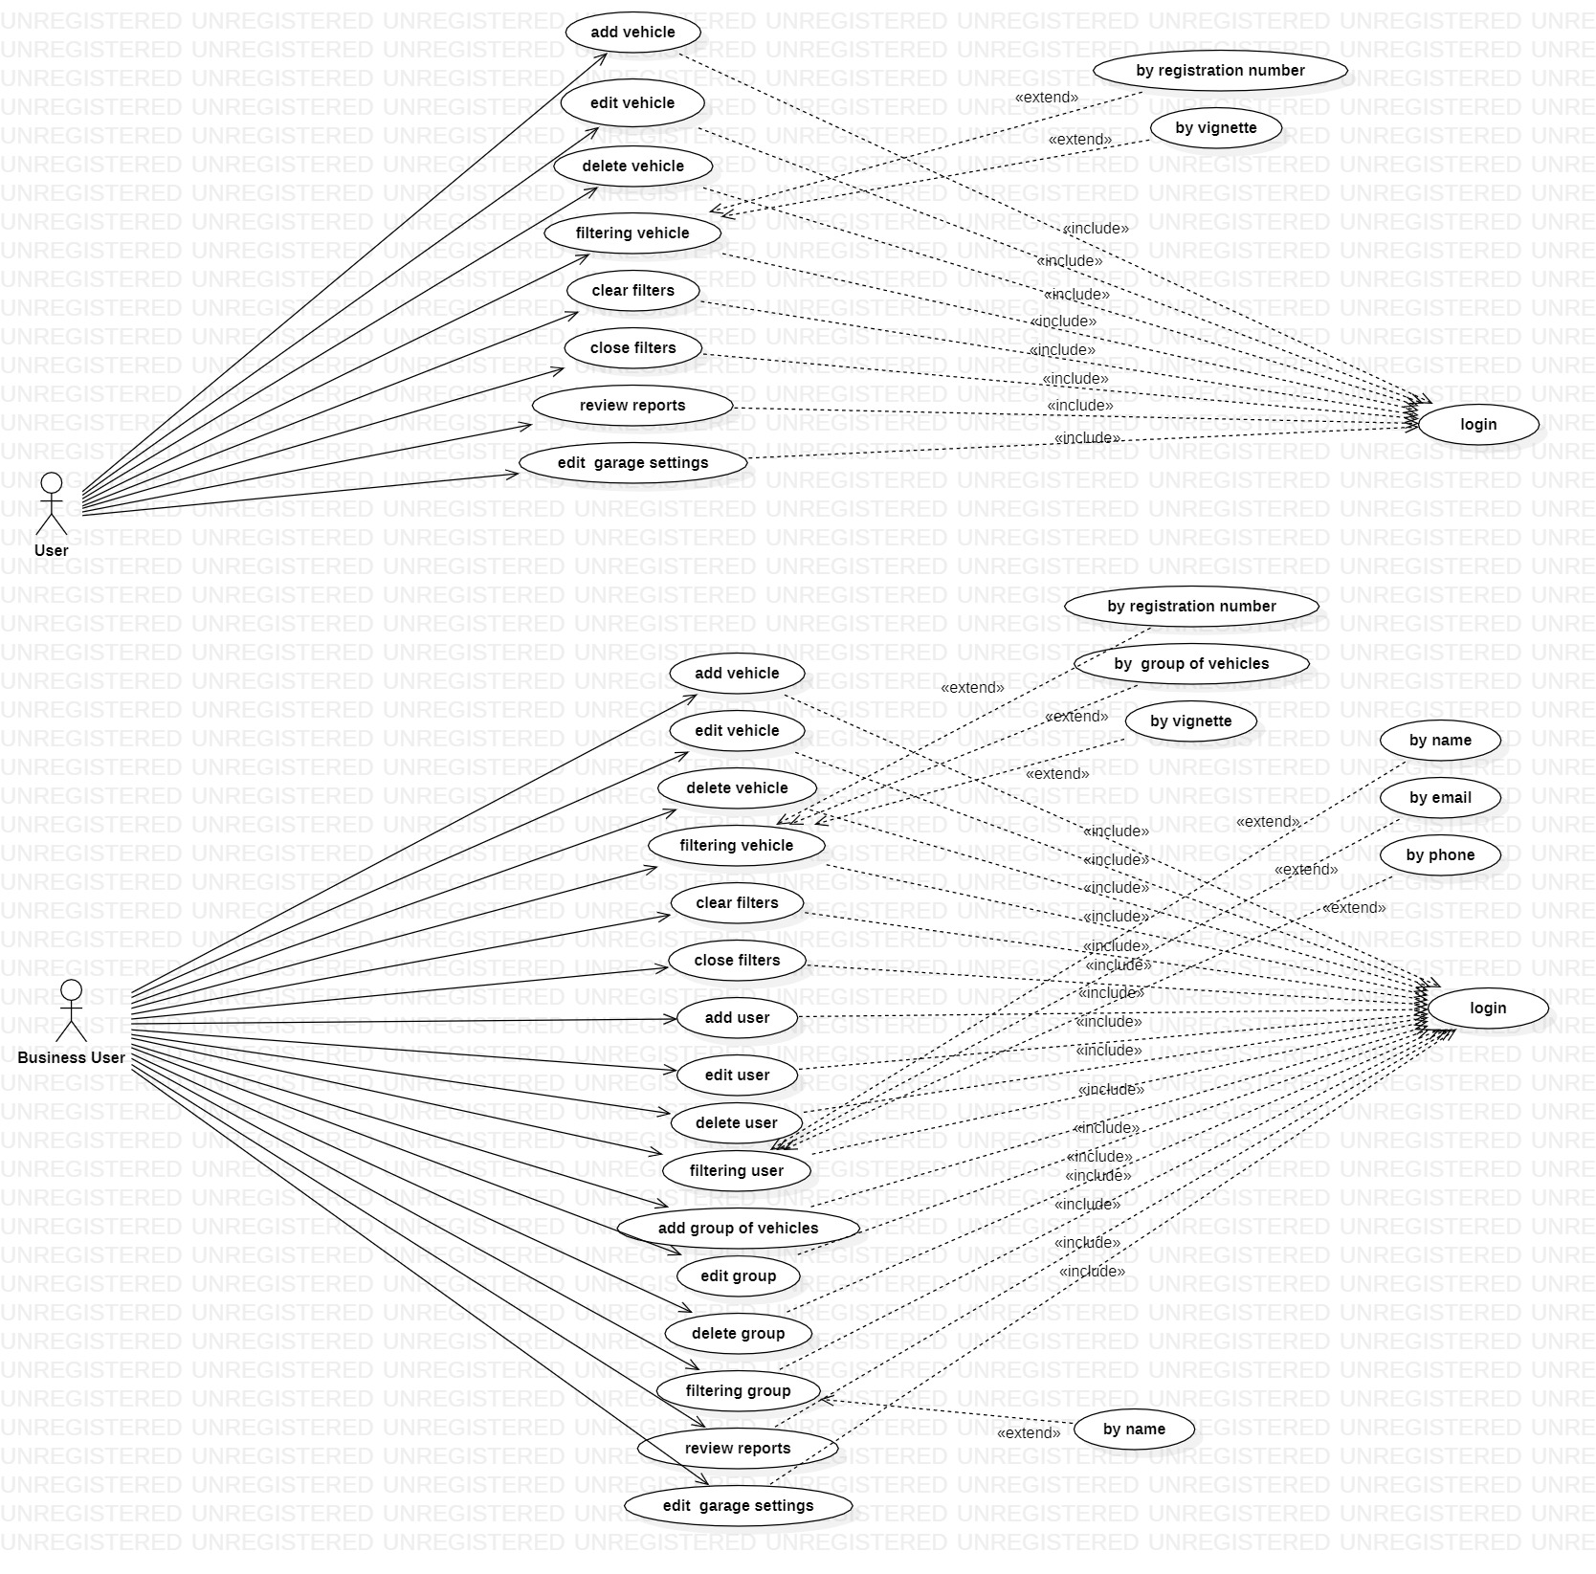

- User: - can create, edit, delete vehicles, view reports, edit his profile and etc., to manage the vehicle he owns.

  - Add new vehicle: - User logs into the Gara6 and add new vehicle in garage.

  - Edit vehicle: - After adding a new vehicle, the user can edit the information about it.

  - Delete vehicle: - When the vehicle information is no longer needed, the user deletes the vehicle.

  - Filtering: - The user selects the criteria for filtering vehicles.

  - Clear filters: - User can clear filters.

  - Close filters: - When the filtering is complete, the user closes the filtering.

  - Review reports: - When needed, the user can view upcoming reports, calendar reports and expenses.

  - Edit garage settings: - The user can edit the garage settings at any time.

- Business user: - The business user can create groups of users and vehicles, also has access to waybills.

  - Add new vehicle: - Business user logs into the Gara6 and add new vehicle in garage.

  - Edit vehicle: - After adding a new vehicle, the business user can edit the information about it.

  - Delete vehicle: - When the vehicle information is no longer needed, the business user deletes the vehicle.

  - Filtering vehicles: - The business user selects the criteria for filtering vehicles.

  - Clear filters: - Business user can clear filters.

  - Close filters: - When the filtering is complete, the business user closes the filtering.

  - Add user: - The business user can add users who have access to garage resources.

  - Edit user: - At any time, the business user can edit the information about a user.

  - Delete user: - When a business user decides, he can delete a user.

  - Filtering user: - The business user can filter by name, email or phone.

  - Add group of vehicles: - When the number of vehicles is large, the business user can group them into groups according to his chosen criteria. He can also create a group of users.

  - Edit group: - When necessary, the user can edit groups of vehicles or users.

  - Delete group: - The business user can delete groups that are no longer used.

  - Filtering group: - The business user can filter groups by name.

  - Review reports: - When needed, the business user can view upcoming reports, calendar reports and expenses.

  - Edit garage settings: - The business user can edit the settings of the garage created by him.

Gantt Chart

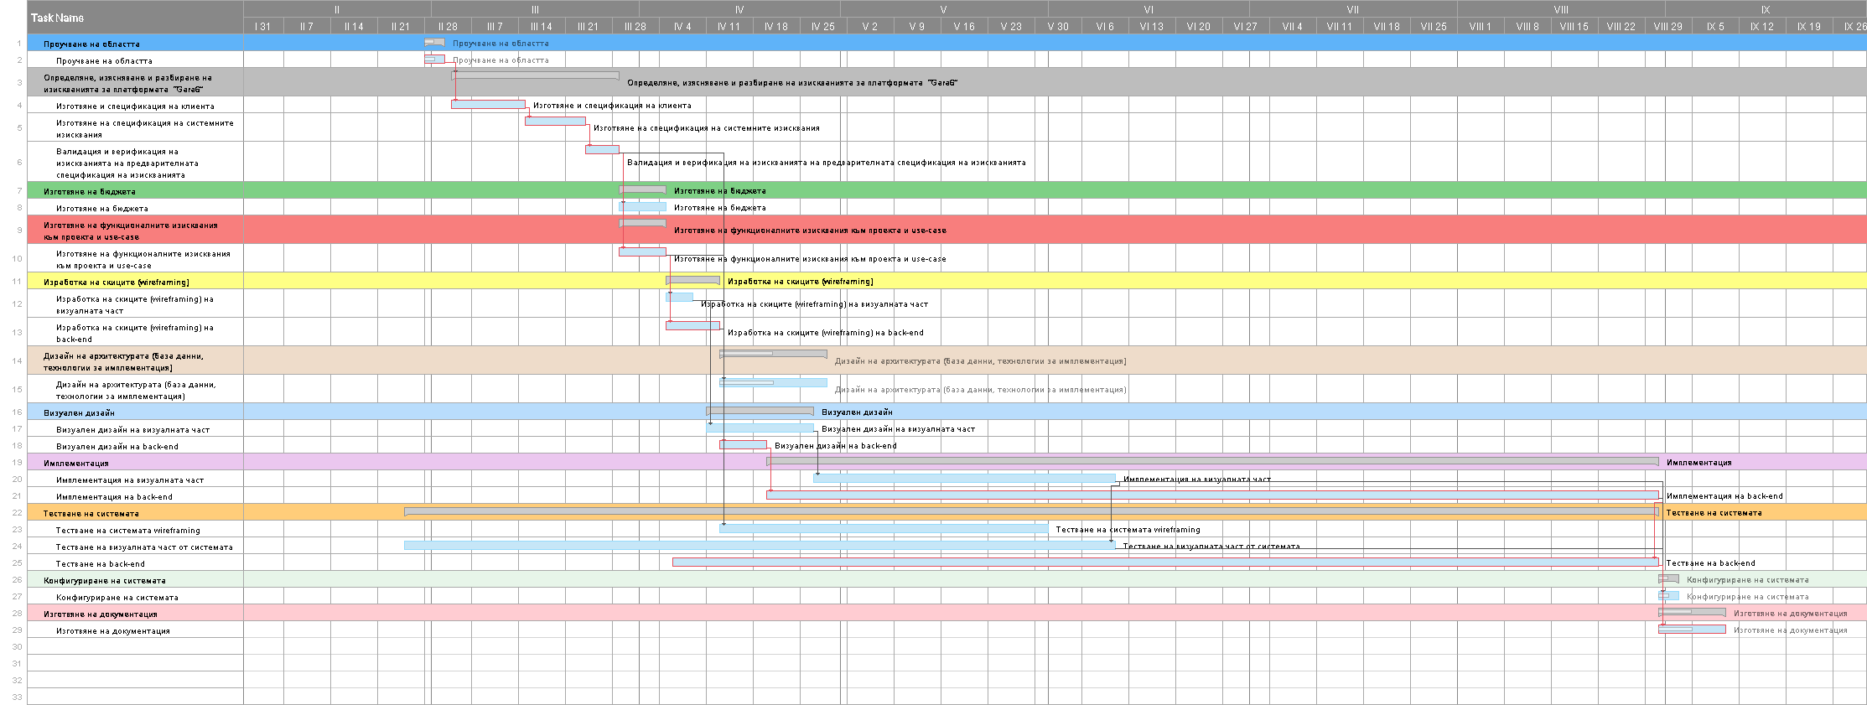

Time table

 | Task | Start | Duration | Type | Dependence
А | Research | Day 0 | 2 days | Coordination
B | Preparation and specification of the client | Day 3 | 7 days | Coordination | А, FS
C | Preparation of specification of system requirements | Day 11 | 7 days | Coordination | B, FS
D | Validation and verification of the requirements of the preliminary specification of the requirements | Day 19 | 3 days | Coordination | C, FS
E | Preparation of the budget | Day 23 | 5 days | Coordination | D, FS
F | Preparation of functional requirements for the project and use-case | Day 29 | 5 days | Coordination | D, FS
G | Wireframing of visual part | Day 35 | 4 days | Parallel | F, FS
H | Wireframing of back-end | Day 35 | 6 days | Parallel | F, FS
I | Architecture design (database, implementation technologies) | Day 23 | 10 days | Parallel | D,F,G,H,FS
J | Visual design of visual part | Day 40 | 10 days | Coordination | G, FS
K | Visual design of back-end | Day 42 | 5 days | Coordination | H, FS
L | Implementation of the visual part | Day 51 | 30 days | Coordination | J, FS
M | Implementation of back-end | Day 35 | 90 days | Coordination | F, FS
N | Testing wireframing | Day 40 | 30 days | Coordination | G, H, FS
О | Testing the visual part of the system | Day 51 | 70 days | Parallel | L, FF
P | Testing the back-end of the system | Day 35 | 100 days | Parallel | M, FF
Q | System configuration | Day 136 | 3 days | Coordination | L, M, FS
R | Preparation of documentation | Day 136 | 7 days | Coordination | O, P, FS

ER diagram

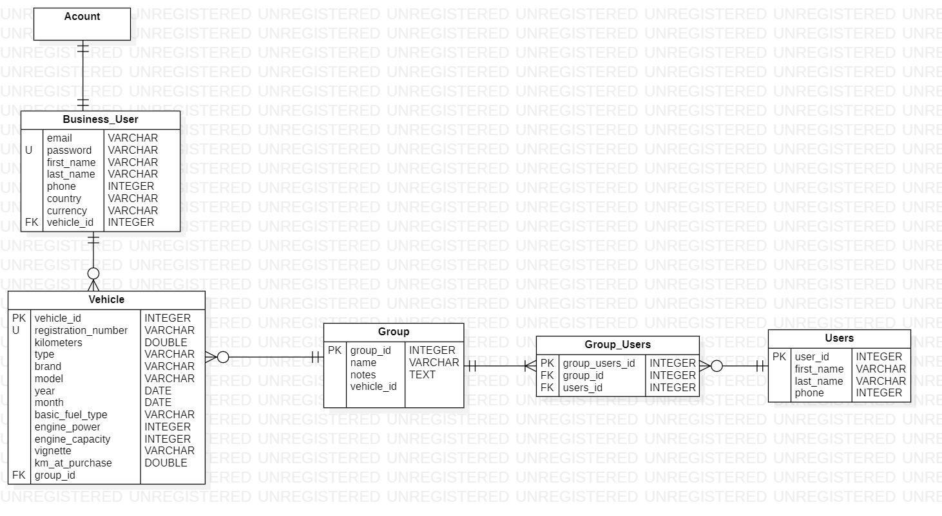

Data Dictionary

Tables used in project

USER_ROLES

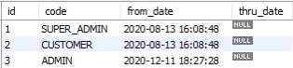

VEHICLE_TYPE

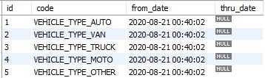

- FILL_TYPE

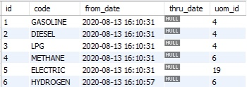

- UNIT_OF_MEASURES

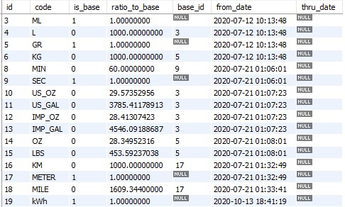

- REPORT_TYPE

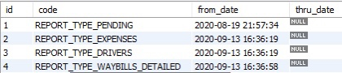

Assumptions and Dependencies

- One user can have one garage with more than one vehicle.

- A business user can create a group of users and vehicles.

Specific Requirements

Use-Case Reports

- User - logs and can add a new vehicle, edit or delete it, filter existing vehicles, view reports and manage settings.

  - Add new vehicle: - User logs into the Gara6 and add new vehicle in garage.

  - Edit vehicle: - User logs into the platform and edits an existing vehicle.

  - Delete vehicle: - User logs into the platform and delete an existing vehicle.

  - Filtering: - The user logs into the platform and filters the vehicles by registration number or vignette.

  - Clear filters: - After filtering vehicles, the user can clear the filters.

  - Close filters: - When the user has finished filtering, he can close the filter.

  - Review reports: - The user logs into the platform and can view upcoming reports, calendar reports and expenses.

  - Edit garage settings: - The user logs into the platform and edit the settings of the garage created by him.

Name of Use Case – Add new vehicle.

Description – A new vehicle will be added in the garage.

Pre Condition – The User should be logged in the system.

Normal Flow of Events –

- A form will open, necessary information will be entered

- A query will be fired to the database.

- Relevant output will be given to the user.

USE CASE DIAGRAM
New Vehicle Details Filled In
Save changes

Work Flow Diagram

New Vehicle Details Filled In

Save changes

Name of Use Case – Edit vehicle.

Description – An already added vehicle will be edited.

Pre Condition - The User should be logged in the system.

Normal Flow of Events –

- A form will open, necessary information will be edited

- A query will be fired to the database.

- Relevant output will be given to the user.

USE CASE DIAGRAM

Vehicle Details Edited

Save changes

WORK FLOW DIAGRAM

Vehicle Details Edited

Save changes

Name of Use Case – Delete vehicle.

Description – An already added vehicle will be deleted.

Pre Condition – The User should be logged in the system.

Normal Flow of Events –

- A form will open, necessary information will be deleted

- A query will be fired to the database.

- Deleted information will no longer be displayed.

USE CASE DIAGRAM

Vehicle Details Deleted

Save changes

WORK FLOW DIAGRAM

Vehicle Details Deleted

Save changes

Name of Use Case – Filtering vehicle.

Description – Filtering of existing vehicles in the platform will be performed.

Pre Condition – The User should be logged in the system.

Normal Flow of Events –

- A form will open, criteria will be selected

- A query will be fired to the database.

- Relevant output will be given to the user.

USE CASE DIAGRAM

Selection of criteria

Vehicles Filtered

WORK FLOW DIAGRAM

Select criteria
Vehicles Filtered

Name of Use Case – Review reports.

Description – The user will choose which of the automatic reports to view.

Pre Condition – The User should be logged in the system.

Normal Flow of Events –

- Will be selected from the criteria specified in the menu.

- A query will be fired to the database.

- Relevant output will be given to the user.

USE CASE DIAGRAM

Selection of criteria

Review reports

WORK FLOW DIAGRAM

Select criteria
Reports reviewed

Name of Use Case – Edit garage settings.

Description – When the form is opened, the information decided by the user will be edited.

Pre Condition – The User should be logged in the system.

Normal Flow of Events –

- A form will open, necessary information will be edited

- A query will be fired to the database.

- Information in the form will be edited.

USE CASE DIAGRAM

Settings Information Edited

Save changes

WORK FLOW DIAGRAM

2. Business User – logs and can add a new vehicle, edit or delete it, filter existing vehicles, view reports, manage settings, create groups of users and vehicles, also has access to waybills
Settings Information Edited

Save changes

  - Add new vehicle: - Business User logs into the Gara6 and add new vehicle in garage.

  - Edit vehicle: - Business User logs into the platform and edits an existing vehicle.

  - Delete vehicle: - Business User logs into the platform and delete an existing vehicle.

  - Filtering vehicles: - The Business User logs into the platform and filters the vehicles by registration number or vignette.

  - Clear filters: - After filtering vehicles, the business user can clear the filters.

  - Close filters: - When the user has finished filtering, he can close the filter.

  - Add user: - The business user logs into the platform and adds users who have access to garage resources.

  - Edit user: - When the business user adds users, he can edit them at any time.

  - Delete user: - The business user selects one user from the created ones and deleted him.

  - Filtering user: - The business user logs into the platform and can filter users by name, email or phone.

  - Add group of vehicles: -The business user logs into the platform and groups the vehicles or users that are created.

  - Edit group: - When necessary, the user edit groups of vehicles or users.

  - Delete group: - The business user logs into the platform and chooses which group to delete.

  - Filtering group: - The business user logs into the platform and can filter users by name.

  - Review reports: - The business user logs into the platform and can view upcoming reports, calendar reports and expenses.

  - Edit garage settings: - The business user logs into the platform and edit the settings of the garage created by him.

Name of Use Case – Add new vehicle.

Description – A new vehicle will be added in the garage, which will be displayed to all the users.

Pre Condition – The Business User should be logged in the system.

Normal Flow of Events –

- A form will open, necessary information will be entered

- A query will be fired to the database.

- Relevant output will be given to the user.

USE CASE DIAGRAM
New Vehicle Details Filled In
Save changes

Work Flow Diagram

New Vehicle Details Filled In

Save changes

Name of Use Case – Edit vehicle.

Description – An already added vehicle will be edited, which will be displayed to all the users.

Pre Condition - The Business User should be logged in the system.

Normal Flow of Events –

- A form will open, necessary information will be edited

- A query will be fired to the database.

- Relevant output will be given to the user.

USE CASE DIAGRAM

Vehicle Details Edited

Save changes

WORK FLOW DIAGRAM

Vehicle Details Edited

Save changes

Name of Use Case – Delete vehicle.

Description – An already added vehicle will be deleted, which will be displayed to all the users.

Pre Condition – The Business User should be logged in the system.

Normal Flow of Events –

- A form will open, necessary information will be deleted

- A query will be fired to the database.

- The information will be deleted from the form.

USE CASE DIAGRAM

Vehicle Details Deleted

Save changes

WORK FLOW DIAGRAM

Vehicle Details Deleted

Save changes

Name of Use Case – Filtering vehicle.

Description – Filtering of existing vehicles in the platform will be performed.

Pre Condition – The Business User should be logged in the system.

Normal Flow of Events –

- A form will open, criteria will be selected.

- A query will be fired to the database.

- Relevant output will be given to the user.

USE CASE DIAGRAM

Selection of criteria

Vehicles Filtered

WORK FLOW DIAGRAM

Select criteria
Vehicles Filtered

Name of Use Case – Add users.

Description – The business user logs into the platform and adds users, who have full access to the resources and assign them to it.

Pre Condition – The Business User should be logged in the system.

Normal Flow of Events –

- A form will open, necessary information will be entered

- A query will be fired to the database.

- The new user will be added in the platform.

USE CASE DIAGRAM

Information will be filled.

User will be added

WORK FLOW DIAGRAM
Information will be filled
User will be added

Name of Use Case – Edit users.

Description – The business user logs into the platform and edit user, which will be displayed to other users.

Pre Condition – The Business User should be logged in the system.

Normal Flow of Events –

- A form will open, necessary information will be edited

- A query will be fired to the database.

- Information about user will be edited.

USE CASE DIAGRAM

Information about user will be edited
Saved changes

WORK FLOW DIAGRAM

Information about user will be edited

Saved changes

Name of Use Case – Delete user.

Description – The business user logs into the platform and delete user, who will no longer have access to the resources.

Pre Condition – The Business User should be logged in the system.

Normal Flow of Events –

- A form will open, necessary information will be deleted

- A query will be fired to the database.

- User information will not be displayed on the platform.

USE CASE DIAGRAM

Information will be deleted
Saved changes

WORK FLOW DIAGRAM

Information will be deleted

Saved changes

Name of Use Case – Filtering users.

Description – Filtering of existing users in the platform will be performed.

Pre Condition – The Business User should be logged in the system.

Normal Flow of Events –

- A form will open, criteria will be selected

- A query will be fired to the database.

- Relevant output will be given to the user.

USE CASE DIAGRAM

Selection of criteria

Users Filtered

WORK FLOW DIAGRAM

Select criteria
Users Filtered

Name of Use Case – Add group of vehicles.

Description – The user creates a group of vehicles according to a criterion of his choice.

Pre Condition – The Business User should be logged in the system.

Normal Flow of Events –

- A form will open, necessary information will be entered

- A query will be fired to the database.

- Relevant output will be given to the user.

USE CASE DIAGRAM

Select criterion
Save changes

Add group

WORK FLOW DIAGRAM
Select criterion
Save changes

Add group
Name of Use Case – Edit group.

Description – The business user logs into the platform and will be edited information about a group.

Pre Condition – The Business User should be logged in the system.

Normal Flow of Events –

- A form will open, necessary information will be edited

- A query will be fired to the database.

- Relevant output will be given to the user.

USE CASE DIAGRAM

Information about group will be edited

Save changes

WORK FLOW DIAGRAM

Group information will be edited

Save changes
Name of Use Case – Delete group.

Description – The business user logs into the platform and delete group, that no one will have access to anymore.

Pre Condition – The Business User should be logged in the system.

Normal Flow of Events –

- A form will open, necessary information will be deleted

- A query will be fired to the database.

- Information about group will be deleted.

USE CASE DIAGRAM

Information about group will be deleted

Save changes

WORK FLOW DIAGRAM

Group information will be deleted
Save changes

Name of Use Case – Filtering group.

Description – Filtering of existing groups in the platform will be performed.

Pre Condition – The Business User should be logged in the system.

Normal Flow of Events –

- A form will open, criteria will be selected.

- A query will be fired to the database.

- Relevant output will be given to the user.

USE CASE DIAGRAM

Selection of criteria

Groups Filtered

WORK FLOW DIAGRAM

Select criteria
Groups Filtered

Name of Use Case – Review reports.

Description – The business user will choose which of the automatic reports to view.

Pre Condition – The User should be logged in the system.

Normal Flow of Events –

- Will be selected from the criteria specified in the menu.

- A query will be fired to the database.

- Relevant output will be given to the user.

USE CASE DIAGRAM

Selection of criteria

Review reports
WORK FLOW DIAGRAM

Select criteria
Reports reviewed

Name of Use Case – Edit garage settings.

Description – When the form is opened, the information decided by the business user will be edited.

Pre Condition – The User should be logged in the system.

Normal Flow of Events –

- A form will open, necessary information will be edited

- A query will be fired to the database.

- Information in the form will be edited.

USE CASE DIAGRAM

Settings Information Edited

Save changes

WORK FLOW DIAGRAM

Settings Information Edited

Save changes

Class Diagram

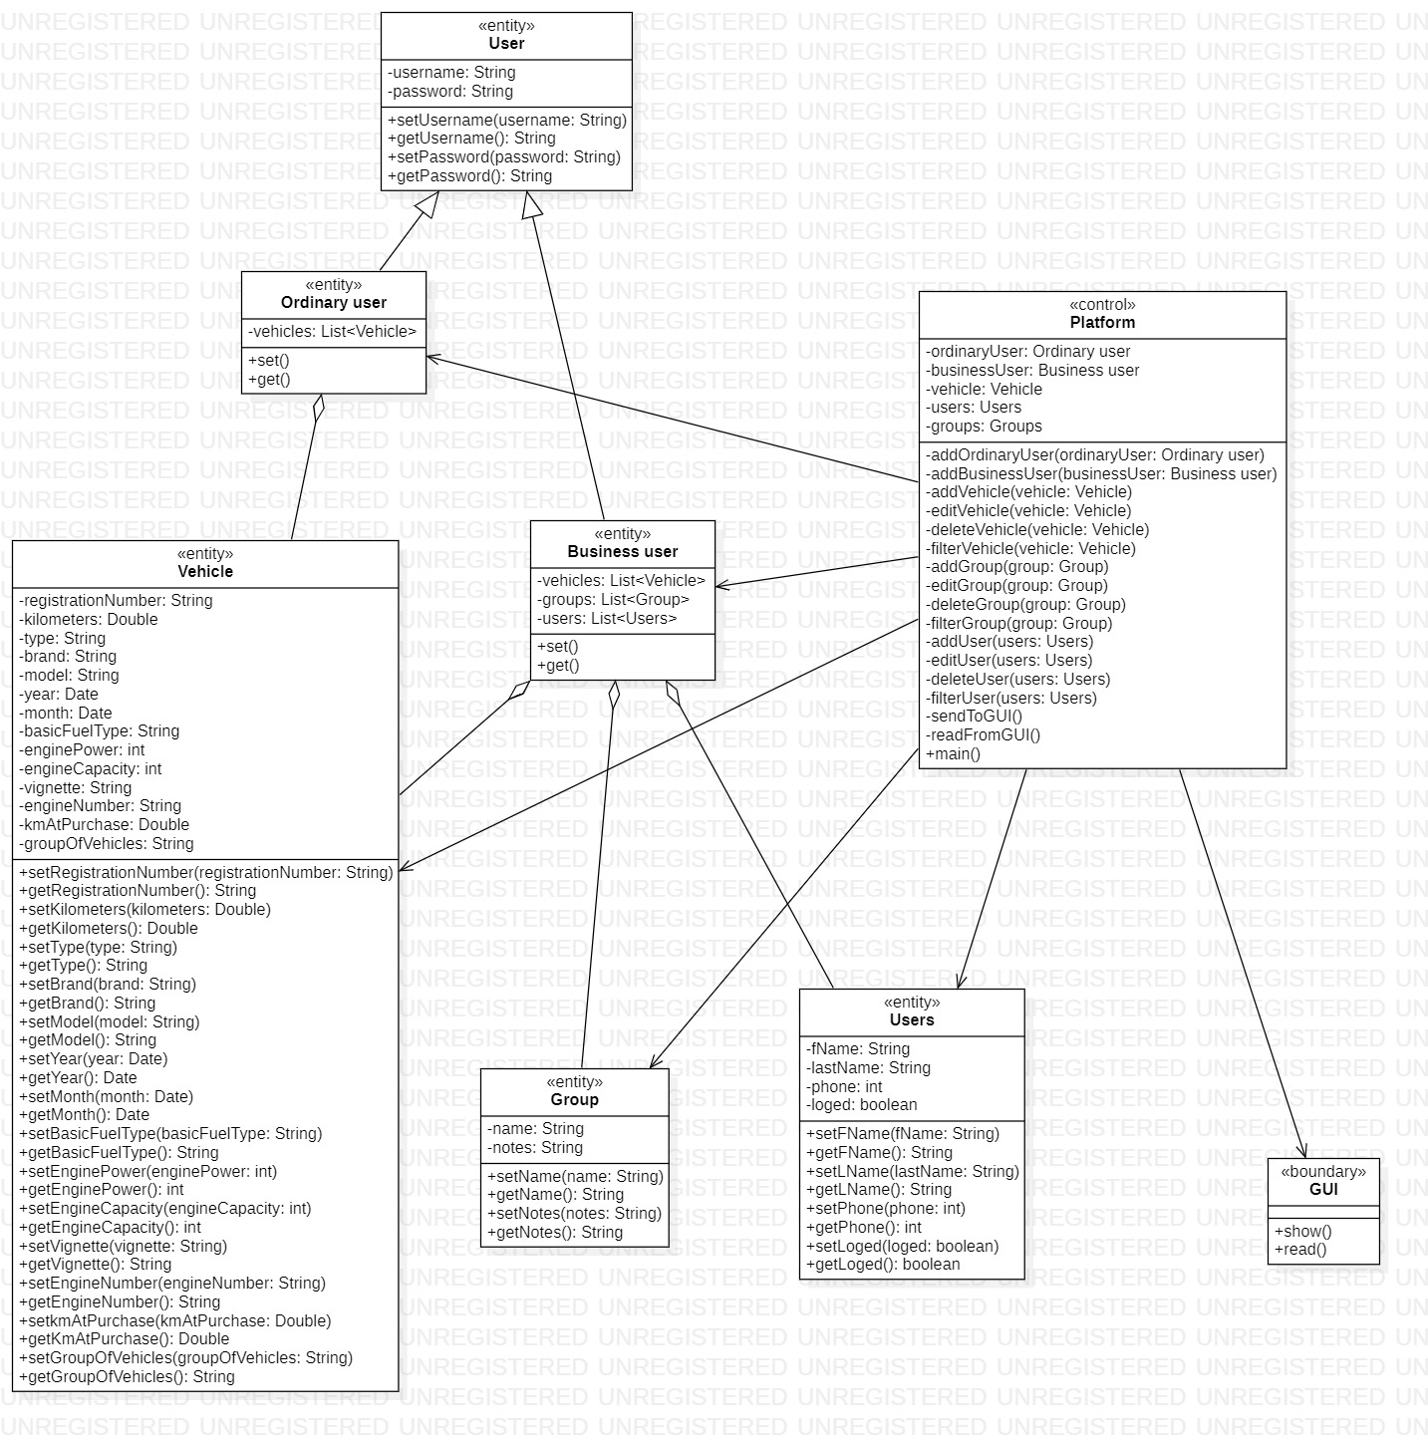

Supplementary Requirements

- Since this is a tool which can be used from anywhere and anytime in the world, so the server should be well managed for such kind of requirement.

- The users using this platform and importing the reports from this tool should have supporting software to run them.

- To use the application in the best possible way please read the tips displayed while using the tool.

